What is The Difference between 1D and 2D Barcode Handheld Terminal?
With the development of economy and information, data added to barcode is more and more, 2D instead of 1D, which could be added to more data. 2D barcode is made up by horizontal and direction code, and other polygon patterns. So, what are the differences between 1D and 2D barcode handheld terminal?
1D barcode is made up by black and white lines, English letters or numbers. It contains basic information of products, such as product name and price, but no more details about products. 1D handheld terminal could scan the basic information of products, but for more details, it should be coordinated with computer and database.
2D barcode contains basic and details of products, which meets the needs of developed industries. For example, if clothing with 2D barcode, with the handheld terminal, we can know price, name, size, materials and other information of clothing. 2D barcode handheld terminal could scan 1D and 2D barcode.
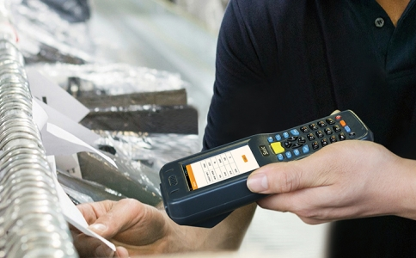
With the before introduction, we can know the differences between 1D and 2D handheld terminal. 1D handheld terminal could only scan 1D barcode, but 2D handheld terminal could scan 1D and 2D barcode.
Seuic is a leading manufacturer of handheld terminal, which is experienced in IOT industry more than 10years. Handheld terminal supplied by Seuic could scan various barcode, not only 1D or 2D barcode, but also worst barcode, which meets the needs of kinds industrial data collection. Handheld terminals are applicated to retail stores, markets, manufacturing, logistic express and other fields.
Article from Seuic (autoid@seuic.com), please indicate the source.

