Handheld Terminal Makes Security Management Intelligent
Internet of Things (IOT) is a new concept in 21st century, which is used in environment protection, public service and daily lives. Internet connects with things by handheld terminals, which could realize the function of connection and transfers. IOT handheld terminal is put into wide industries, which is popular all over the world.
With the development of IOT technology, automatic recognition technology is moving towards to the direction of digitalization, information and intelligence. IOT improves the usage of data, which connect the internet with perception. Intelligence is closely related to data. The degree of intelligence increases with the deepening of data computing and application, and brings more intense feeling to users.
It is a good chance for security field. It could realize the functions of local intelligence, share and characteristic sensing with intelligent security. Handheld terminal is the terminal of IOT, which could collect data and share data to computer, realize the function of connection between things and internet. Handheld terminal used in intelligent security is the hot topic, which could be promoted the development of security.
Seuic is a leading manufacturer of handheld terminal and industrial solution, with experience in IOT terminal. Handheld terminal supplied by Seuic is applicated to logistic express, manufacturing, retail chain, medical, public service and so on, which make the data collecting more easily.
New AUTOID9 handheld terminal advantages
Advanced capacitive touch and visual experience:
It could fully meet the indoor and outdoor clear visual needs with 4inch capacitive touch screen, low temperature IPS full angle display. The combination of support gloves, wet hand touch, practical and quick physica, could meet the extreme cold, rain, dust and other environments for operational requirements.
Thin experience and easy to carry:
It has combined ergonomic design and industrial design, with 270g weight, easy to carry.
Combination of practical and quick physical keyboard:
There are two key style for choose, one is striking shield scanning keys, another is digital shortcut key. Users could choose the keys with the habits and hobbies.
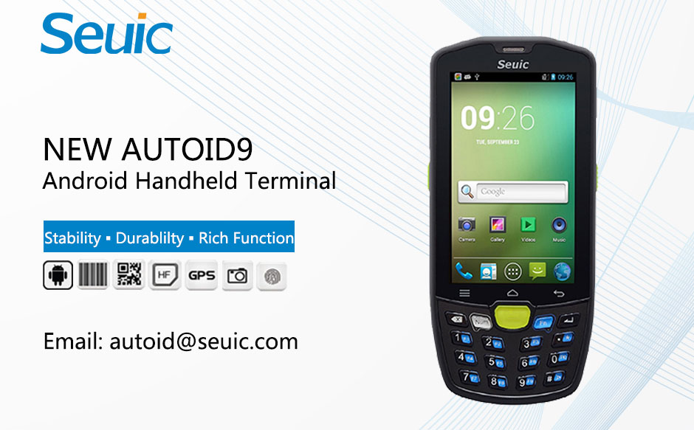
Data security without vulnerability:
AUTOID 9 series have the device unified management function, on-demand control locks, the remote antivirus and clears the suspicious process.
Perfect Bar code solution:
AUTOID 9 supports the most professional scanning engine, and support MOTO SDC soft scanning technology, parses the barcode through Camera. Its scanning speed is no less than the scanning engine.
Stable Android 5.1 and extremely fast four-code CPU:
With the professional system optimization design, it completely solved the problem of system memory consumption of Android. AUTOID 9 is suitable for kinds developing of Apps. It could be easy to work with each task instruction, allowing multiple tasks to run smoothly, with the four-code 1.2GHz CPU. AUTOID 9 could guarantee the mobile information processing.
Reliable industrial protection design:
According IP67 seal standard, AUTOID 9 could withstand the impact of falling from 1.5m height to the ground, use under the rain, snow and dust weather. It could still show a stable and reliable performance after 1000times rolling.
12 hours continuous work:
AUTOID 9 has 4000mAh lithium ion intelligent battery, it supports 12 hours continuous work.
Article from Seuic (autoid@seuic.com), please indicate the source.

