How to Choose The Function of Handheld Terminal?
With the development of IOT, the application of handheld terminal is more and more wide. But, the quality of handheld terminals in the market are much different, so how to distinguish the quality? SEUIC is glad to share some tips.
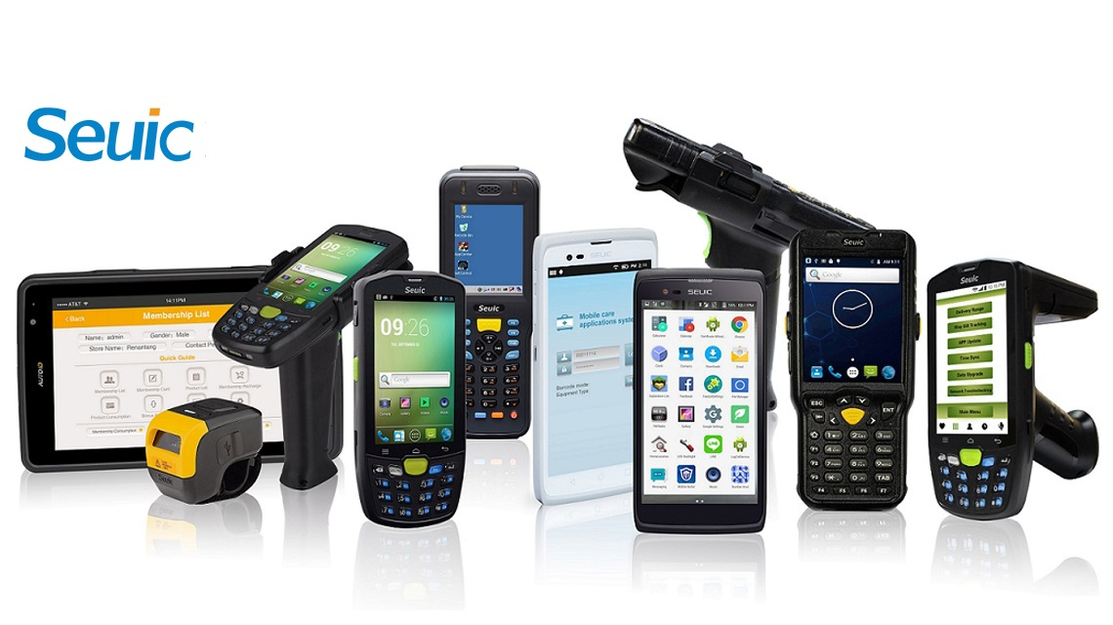
Firstly, function of RFID
It is very important to choose the RFID, as it is the main function of handheld terminal. It should be selected according to the projects, with the requirements of reading distance and signal intensity. There are HF and UHF handheld terminal, for HF one, the reading distance is 3-5cm, for UHF, the reading distance is 0-6m.
Secondly, scan head
There are different scan heads for different projects, for 2D barcode scanning, if without special requirements, normal scan head with 2D scanning software could realize the function for 2D barcode scanning.
Thirdly, protection grade
Handheld terminals are used in the industrial environment, it could be stable operated with high protection grade. For example, the protection grade of AUTOID 9 supplied by SEUIC is IP67, which could be used in various difficult environment.
Fourthly, OS selection
There are Android and Windows OS for handheld terminals, they are the most popular OS in the market. For Android OS, it supports second develop by customers, with open and free advantage. For Windows OS, it supports more stable operation.
Fifthly, resolution ratio of screen
It could support software better and better operation vision, which could improves the satisfaction of customers. As well, suitable light will protect operators’ eyes.
With the usage of handheld terminal, it could improve the efficiency, reduce the cost and time.
Article from Seuic (autoid@seuic.com), please indicate the source.

