Introduction to The Use of Handheld Terminal
Handheld terminal could collect and handle data, with advantages of real-time, availability and facticity. Handheld terminal is also called handheld terminal, inventory machine, PDA and barcode scanner. Seuic supplies various handheld terminals, such as AUTOID 9, AUTOID PAD, CRUISE 1 and so on. All AUTOID series handheld terminal could collect code information and handle data, with Android or Windows OS. With GPRS, blue tooth, WIFI transmission, data could be sent to the system any time. Instructions of handheld terminal will be listed, with the AUTOID 9 as sample.
Firstly, appearance
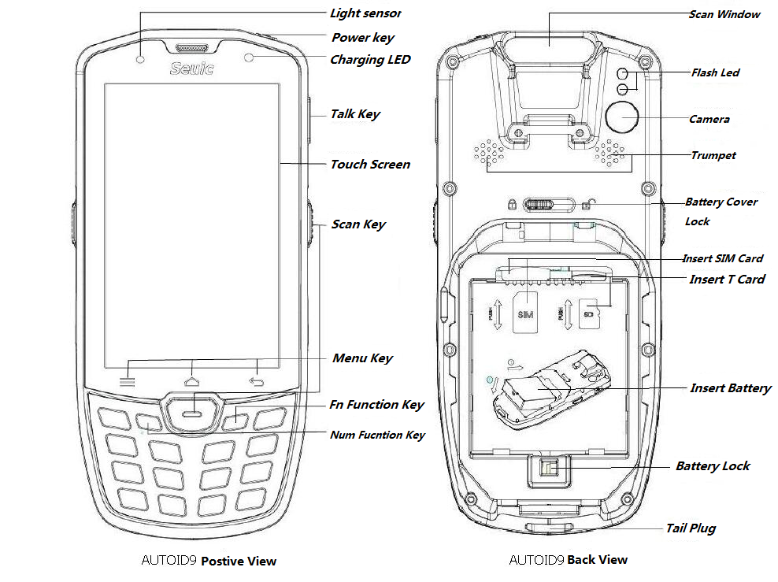
Secondly, steps of usage.
Before usage
Putting battery and closing the cover, then put the power key long time. The system is under the operative mode, if you touch power key, machine will be into a dormant state. Under the dormant state, touching the Power key, the system wakes up and the screen lights.
Starting up
It could start machine with the touch of power key. Under the deep dormancy mode, it could wake up the system with the touch of power key. During the usage, please ensure the battery cover is closed.
Shut down
First, press the power key 2 seconds, touch the option menu. Secondly, click the shut down key, it will be shut down. Attention: all the operations should be done under non-dormant state.
Restart
First, press the power key 2 seconds, touch the option menu. Secondly, click the restart key, it will be restarted. Attention: all the operations should be done under non-dormant state.
Assembling battery
AUTOID 9 with the detachable design, it could unscrew four battery cover screws to change battery.
Regular battery replacement is not recommended.
NFC function:With the NFC function, data could be shared with other terminals. And with NFC software, it could read and write the RFID label.
Scanning tool:It could scan with the function of scanning, and set the barcode to scan the kinds of codes. And scan time, scan modes could be set as requirements.
Thirdly, notification.
Even with the waterproof and dustproof functions, AUTOID 9 handheld terminal should not be used in supreme weather.
Do not touch the screen heavily.
For first usage, it should to charge long time to fill the battery.
If any hitches, contact with attendant.
Article from Seuic (autoid@seuic.com), please indicate the source.

