The Massive Growth of Smart Home and Internet of Things
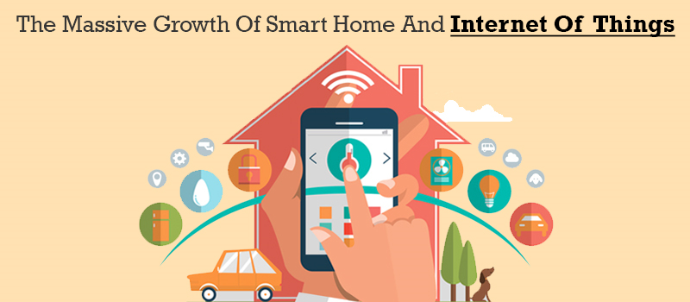
IoT and Smart Home has become an important part of every aspect of our lives. In addition to these, Internet of Things applications are also introduced to enhance our comfort by giving us more control to simplify routine work life.
Internet of Things and Smart Home technology enables owners to customize and control their home environments. It is now proving to be a powerful enhancement in technology. There are already hundreds of IoT apps development companies available to monitor and build smart homes.
When we think of the next step in technology evolution, Smart Homes and IoT always comes in the picture as it has a major hand in technology enhancement. The trend began in 1920’s, by introducing machines like vacuum cleaners, food processors and sewing machines highlighting the convenience and time savings.
Major evolution was in 90’s with an announcement of internet refrigerators or smart refrigerators installed with calendar updates, emails, television and personal finance terminal, which failed to satisfy consumers as the similar services were being used on different devices also.
Later in 2010, Nest (Acquired by Google later) announced smart thermostats and smoke alarms which gained huge acceptance due to its fine-tuned design and ability to control temperature as per human behavior and trend without many efforts. Moving to next, smart home category incorporated with Smart Things (Acquired by Samsung) having capability of connecting nearly all the connected gadgets at home gained quite enough popularity.
The giants like Google (Google Home), Amazon (Amazon Echo), Microsoft (Lab of things) and Tesla (Smart wall and solar tiles) also put their efforts into investing and researching heavily in the hope of making smart homes a possible dream with smart products. These Smart Home appliances are integrated with IoT, hence IoT app development is suppose to have a leading trend in apps world.
IoT has a big hand in smart home evolution. It states how technology can be used by integrating into simple everyday objects and how the objects are automated with sensors. The Market trends regarding smart homes and IoT are broad with independent household appliances. These self-sufficient devices will be integrated with the latest technology, to get a realistic ‘smart home’ experience.
The IoT Apps Development Companies are gaining high attention due to this massive enhancement in IoT and Smart Home technologies. Considering the major role of IoT apps in Smart Home appliances, IoT app development will be a leading trend in apps world.
According to statistics, the purchases of the smart home device are expected to grow from 83million in 2015 to 193 million by 2020. The smart home appliances like washing machines, microwaves, coffee machines etc, the smart home security solutions like sensors, locks, alarm systems and cameras, and the smart home energy equipment, like smart thermostats and lighting, are incorporated in it. The smart home controlling will lay in electricity management, lighting control and temperature control and security systems.
The three areas Home utility systems, appliances and safety devices are uncovering both individual and society wide benefits. They include financial savings, enhance convenience, and contribute to more ecological and sustainable living, sense of safety and security and more.
So what are you waiting for? Come up with your unique idea of developing internet of things mobile app and connect with one of the best IoT apps development companies.
Get in Touch with us
Web Site - https://excellentwebworld.com/
Email: sales@excellentwebworld.com
Follow us

