How to Choose the OS of Handheld Terminal?
Handheld terminal could be divided into Industrial PDA and consumer PDA. Industrial handheld terminal is most used in industrial fields, such as industrial PDA, barcode scanner, RFID handheld terminal. Industrial handheld terminal is rugged, could be used in difficult environment. Industrial handheld terminal supports RFID and barcode scanning, with IP67 grade of protection, which are different from consumer handheld terminal.
In the below lists, it will main talk about the OS of industrial handheld terminal. There are Android, Win Mobile and Win CE system for handheld terminal.Which OS is better for handheld terminal?
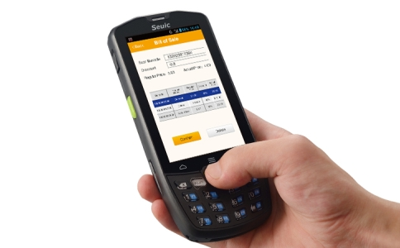
Firstly, Android OS.
Android OS is more free, which supports the second develop for users.
Secondly, Win CE OS.
Windows CE is developed by Microsoft, which is 32bit embedded operating system, with free and scalable characters, most used in handheld mobile computer. Win CE OS is much stable, but the function of screen touch is not as good as Android.
Thirdly, Win Mobile OS.
Windows Mobile OS is developed for industrial handheld terminal by Microsoft, with function of Win CE and applications of upper layer device. Win Mobile OS supplies a good platform for companies, with hardware, develop tool and long-time usage of battery.
Win CE and Win Mobile OS is main used in warehouse management, logistic express, inventory, store inspection and others. With the development of IOT, Android handheld terminal is wide used, with free and developed characters. When select the OS, it could be according to item requirements, functions and budget.
Seuic is a leading manufacturer of handheld terminal, with research team and producing team, ensure the high quality and various function. Handheld terminal supplied by SEUIC are used in logistic, warehouse, manufacturing, public, medical, agriculture, retail and so on, supports 1D, 2D barcode, NFC reading, RFID reading, which is certified by IP67 protection grade testing.
Article from Seuic (autoid@seuic.com), please indicate the source.

